**Chapter 6**

**Power Series**

**6.1 Power Series and Functions**

**Section Exercises**

**In the following exercises, state whether each statement is true, or give an example to show that it is false.**

1. If  converges, then  as 

Answer: True. If a series converges then its terms tend to zero.

3. Given any sequence  there is always some  possibly very small, such that  converges on 

Answer: False. It would imply that  for  If , then  does not tend to zero for any 

5. Suppose that  converges at  At which of the following points must the series also converge? Use the fact that if  converges at *x*, then it converges at any point closer to *c* than *x*.

1. 
2. 
3. 
4. 
5. 
6. 

Answer: It must converge on  and hence at: a.b.c.d.e. and f.

**In the following exercises, suppose that  as  Find the radius of convergence for each series.**

7. 

Answer:  so

9. 

Answer:  so 

11. 

Answer:  so 

**In the following exercises, find the radius of convergence *R* and interval of convergence for  with the given coefficients 

13. 

Answer:  so . so  When  the series is harmonic and diverges. When  the series is alternating harmonic and converges. The interval of convergence is 

15. 

Answer:  so  so  When  the series diverges by the divergence test. The interval of convergence is 

17. 

Answer:  so When  the series diverges by the divergence test. The interval of convergence is 

19. 

Answer:  so  When  the series is an absolutely convergent *p*-series. The interval of convergence is 

21. 

Answer: ,  so the series converges for all *x* by the ratio test and 

**In the following exercises, find the radius of convergence of each series.**

23. 

Answer:  so  so .

25. 

Answer:  so  so 

27.  where 

Answer:  so  so 

**In the following exercises, use the ratio test to determine the radius of convergence of each series.**

29. 

Answer:  so 

31. 

Answer:  so  so 

**In the following exercises, given that  with convergence in  find the power series for each function with the given center *a*, and identify its interval of convergence.**

33. ;  (*Hint:*)

Answer:  on 

35. ; 

Answer:  on 

37. ; 

Answer:  on 

39. ; .

Answer:  on 

41. ; 

Answer:  on 

**Use the next exercise to find the radius of convergence of the given series in the subsequent exercises.**

43. Explain why, if , then  whenever  and, therefore, the radius of convergence of  is 

Answer:  as  and  when  Therefore,  converges when  by the *n*th root test.

45. 

Answer:  so  so 

47. 

Answer:  so  so 

49. Suppose that  such that  if *n* is odd. Explain why 

Answer: We can rewrite  and  since 

51. Suppose that  converges on  Find the interval of convergence of 

Answer: If , then  so  converges.

**In the following exercises, suppose that  satisfies  where  for each *n*. State whether each series converges on the full interval  or if there is not enough information to draw a conclusion. Use the comparison test when appropriate.**

53. 

Answer: Converges on  by the ratio test

55.  (*Hint:* Let  if  for some *n*, otherwise .)

Answer: Consider the series  where  if  and  otherwise. Then  and so the series converges on  by the comparison test.

57. **[T]** Plot the graphs of  and of the partial sums  for  on the interval  Comment on the approximation of  by  near  and near  as *N* increases.

Answer:

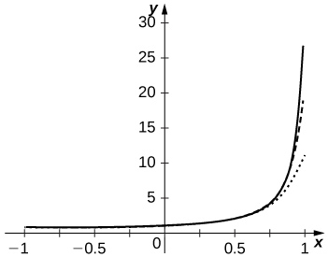

The approximation is more accurate near . The partial sums follow  more closely as *N* increases but are never accurate near  since the series diverges there.

59. **[T]** Plot the graphs of the partial sums  for  on the interval  Comment on the behavior of the sums near  and near  as *N* increases.

Answer:

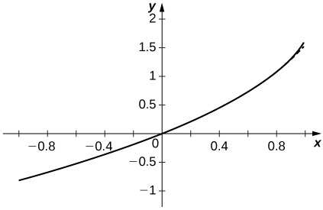

The approximation appears to stabilize quickly near both .

61. **[T]** Plot the graphs of the partial sums  for  on the interval  Comment on how these plots approximate  as *N* increases.

Answer:

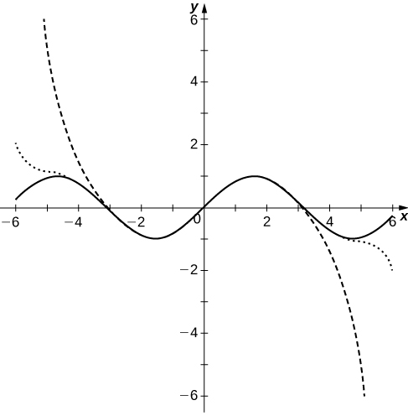

The polynomial curves have roots close to those of  up to their degree and then the polynomials diverge from .

This file is copyright 2016, Rice University. All Rights Reserved.